**CS5200 Spring 2018 Homework 6**

Due Tuesday, May 01,2018, 11:59 PM

Xiongming Dai

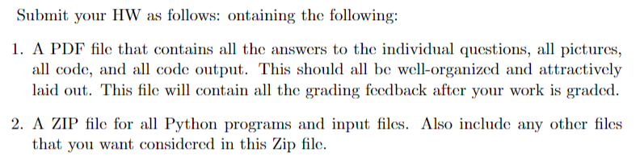

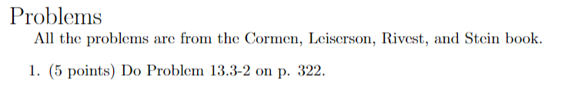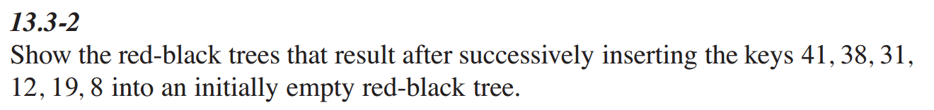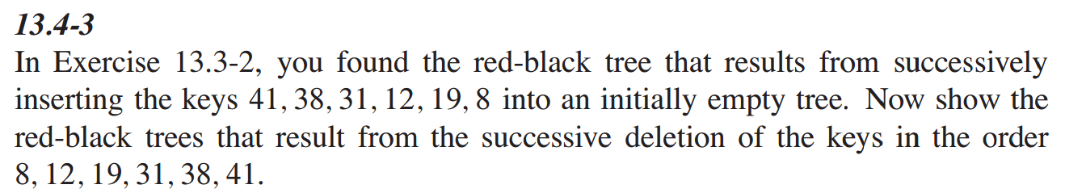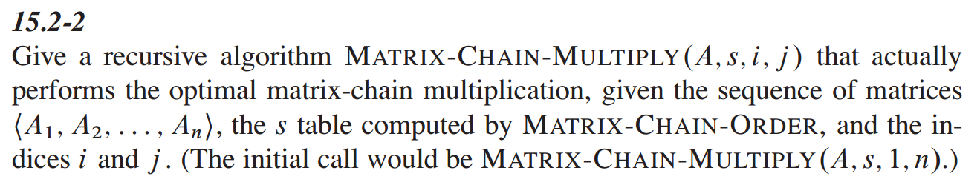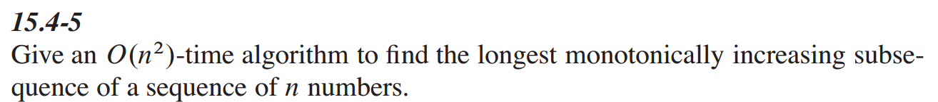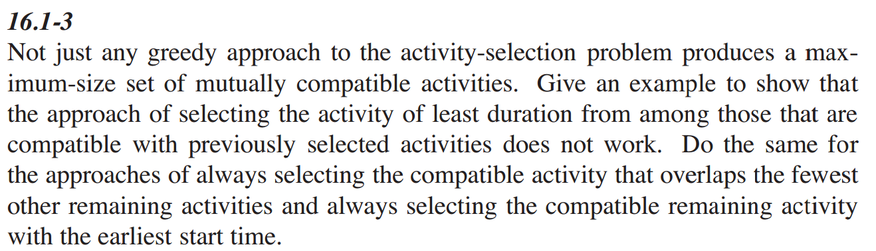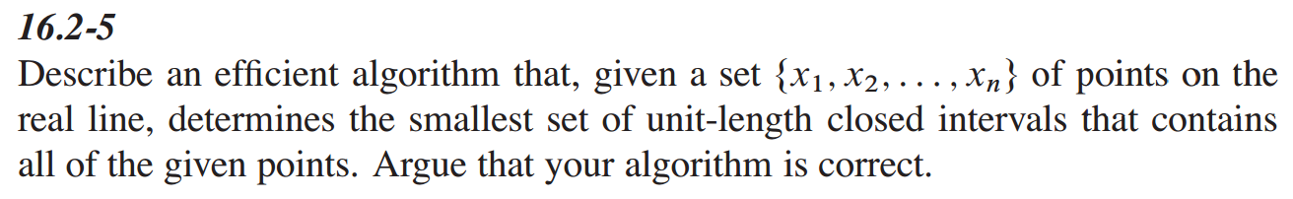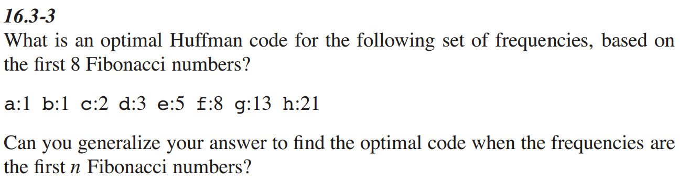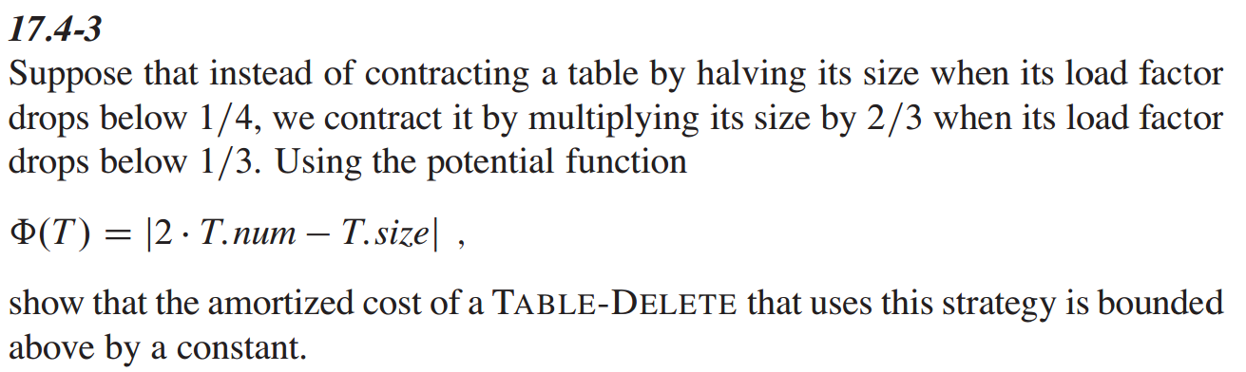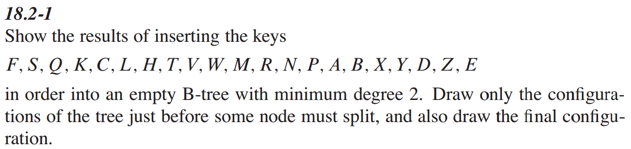Page 502 not page 350

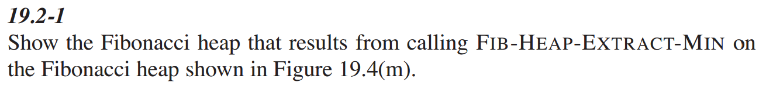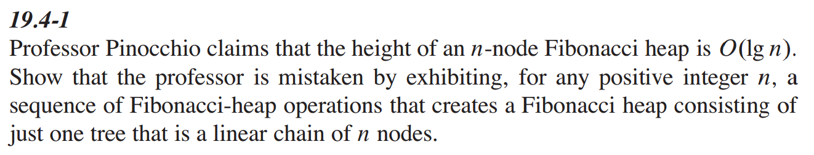

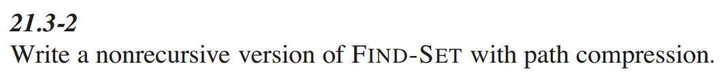

**<end>**